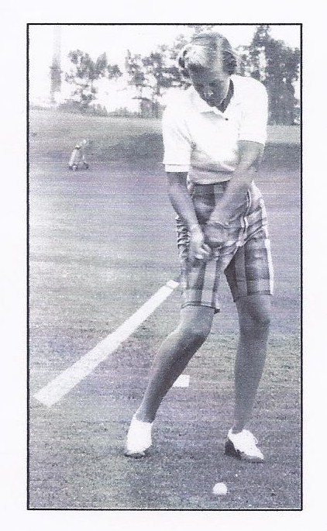20TH ANNUAL
JEAN FORSYTH MEMORIAL
GOLF TOURNAMENT

THURSDAY, JULY 18, 2019

RAIN DATE: THURSDAY, AUGUST 8th

9:00 AM SHOTGUN

GREEN MEADOWS GOLF COURSE
RTE. 20 & BRICKYARD RD., NORTH EAST, PA
814-725-5009

JUNIOR GIRLS: ANY FEMALES AGES 9 TO 17
** NO ENTRY FEE – NO GREENS FEE **

Sponsored by: The Vorsheck Family Foundation

IN MEMORY OF JEAN FORSYTH &
11-YEAR TOURNAMENT DIRECTOR, BARB BEHAN

TO ENTER: EMAIL GREENMEADOWSGC@AOL.COM OR CALL 814-725-5009
NAME : ___________________________________________ AGE GROUPS:
PARENT’S PHONE: ____________________________________________ AGES 9-10........7 HOLES
AGE: __________________________________________________ AGES 11-13......9 HOLES
EMAIL __________________________________________________ AGES 14-17......18 HOLES

AVG SCORE FOR 9/18 HOLES _______ # OF TIMES/WEEK YOU PLAY GOLF ______

ENTRIES MUST BE RECEIVED BY JULY 11, 2019

